**Clase: Diagramas de Ishikawa**

*#*

*Se*

*activa*

*librería*

*qcc*

**library**

(

qcc

)

##

Package

'qcc',

version

2.6

##

Type

'citation("qcc")'

for

citing

this

R

package

in

publications.

*#*

*Se*

*elabora*

*el*

*diagrama*

*de*

*Ishikawa*

cause.and.effect

(

cause

=

list

(

Measurements

=

c

(

"Micrometers"

,

"Microscopes"

,

"Inspectors"

)

,

Materials

=

c

(

"Alloys"

,

"Lubricants"

,

"Suppliers"

)

,

Personnel

=

c

(

"Shofts"

,

"Supervisors"

,

"Training"

,

"Operators"

)

,

Environment

=

c

(

"Condensation"

,

"Moisture"

)

,

Methods

=

c

(

"Brake"

,

"Engager"

,

"Angle"

)

,

Machines

=

c

(

"Speed"

,

"Lathes"

,

"Bits"

,

"Sockets"

))

,

effect

=

"Surface

Flaws"

)

*##*

*Otro*

*método:*

**library**

(

SixSigma

)

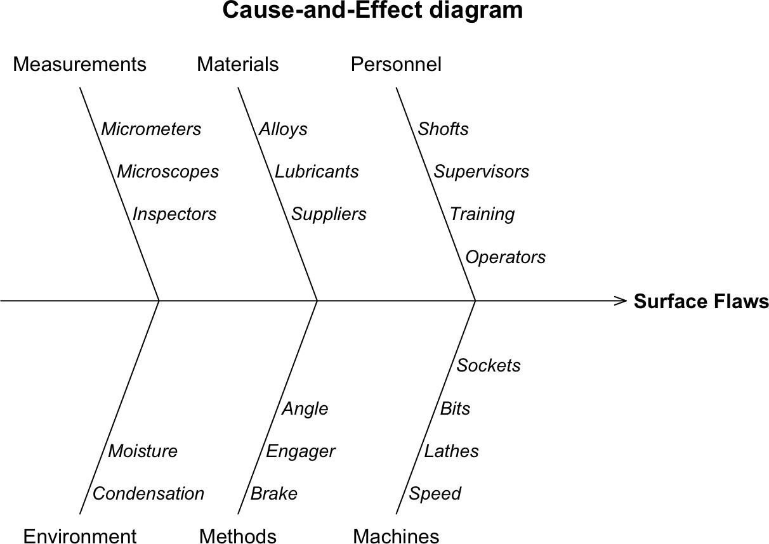

1/3

*# Se elabora el diagrama* effect <- "Flight Time" causes.gr <- c("Operator", "Environment", "Tools", "Design",

"Raw.Material", "Measure.Tool")

causes <- vector(mode = "list", length = length(causes.gr)) causes[1] <- list(c("operator #1", "operator #2", "operator #3")) causes[2] <- list(c("height", "cleaning")) causes[3] <- list(c("scissors", "tape")) causes[4] <- list(c("rotor.length", "rotor.width2", "paperclip")) causes[5] <- list(c("thickness", "marks")) causes[6] <- list(c("calibrate", "model"))

ss.ceDiag(effect, causes.gr, causes, sub = "Paper Helicopter Project")

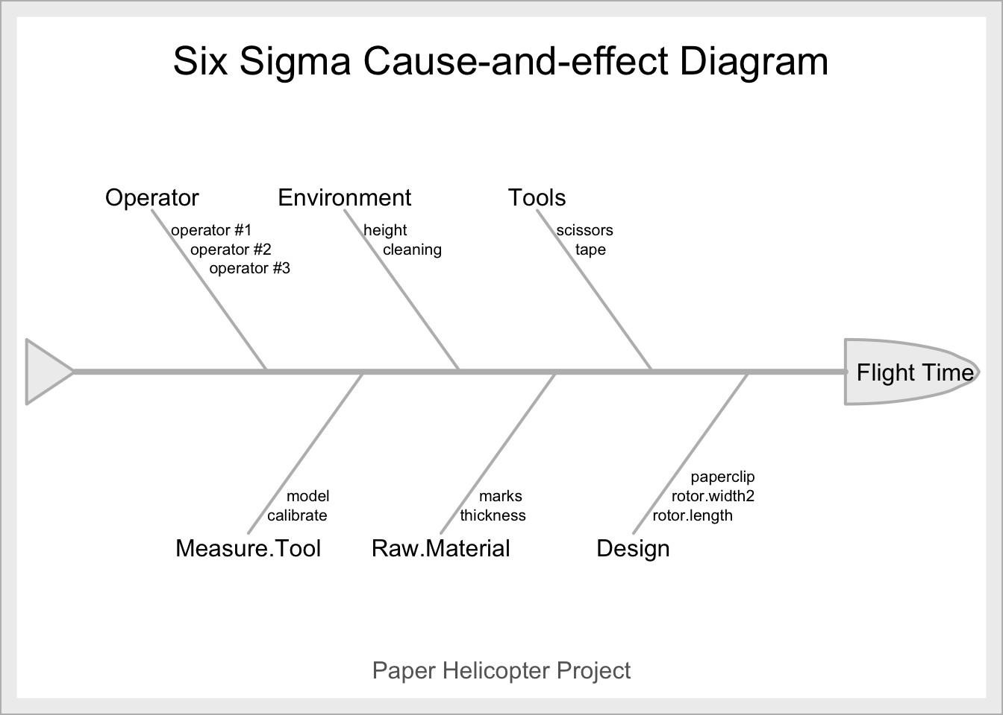

2/3